Day 2 Assignment
Abhinaash Tiwari
2 December 2, 2025

Tasks
- Create schema org.
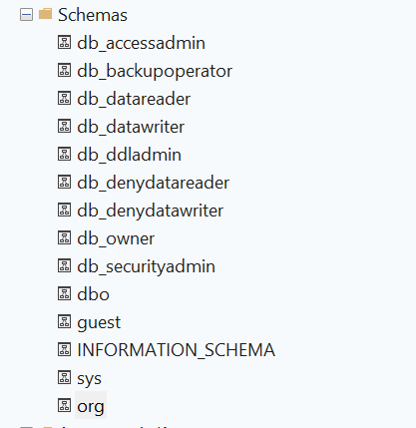
- Create table Branches with PK, UNIQUE, DEFAULT constraints.
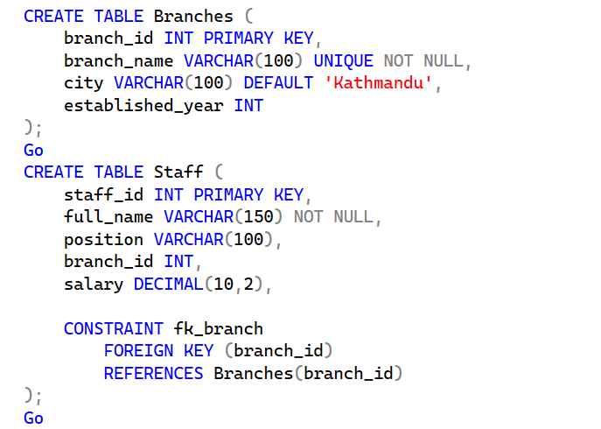

- Create table Staff with FK to Branches.
- Insert 3 branches and 5 staff members.
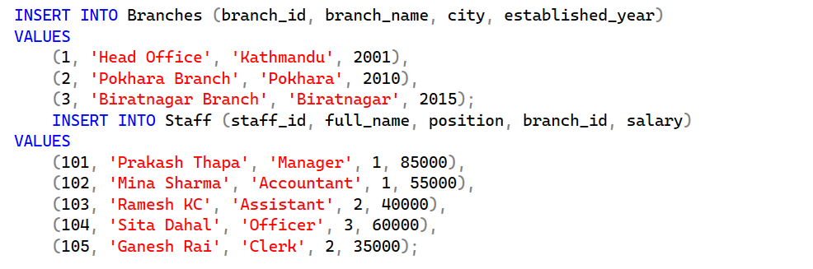

Output from Select * :
